B.K. Jewellers

**Business Requirement Document (BRD)**

**Document for**

**“Stock management” part.**

Document NO: 001

Date: 13-02-2020

Prepared by:

Group 2

* **Revision History**

|  |  |  |  |
| --- | --- | --- | --- |
| **Revision Number** | **Revision Date** | **Summary of changes** | **Author** |
| **1** | 13/02/2020 | Document made. | Vrajrajsinh jadeja |
| **2** | 18/04/2020 | * **Table of content:** Page numbers added. * **(2.2):** Number of users updated. * **(8):** Note is updated. | Rudra soni |
| **3** |  |  |  |
|  |  |  |  |

* **Table of Contents** -

|  |  |  |
| --- | --- | --- |
| Sr no. | Content | Page no. |
| 1. | Introduction |  |
|  | 1.1 Purpose | 4 |
|  | 1.2 Scope | 4 |
|  |  |  |
| 2. | General business requirements |  |
|  | 2.1 General requirement | 4 |
|  | 2.2 User characteristics | 5 |
|  |  |  |
| 3. | Process description | 5 |
|  |  |  |
| 4. | Business requirements | 7 |
|  |  |  |
| 5. | Use case diagram | 8 |
|  |  |  |
| 6. | Business data model | 8 |
|  |  |  |
| 7. | Accuracy | 9 |
|  |  |  |
| 8. | Impacts | 9 |

1. **Introduction**
   1. Purpose:

The purpose of making this document is to make regular activities easier performed by stock management department in organization.

This part of software is used by only stock manager who does the daily stock management activities in organization.

* 1. Scope:

The scope of this business requirement document is bounded to only “stock management department” of **B.K. Jewellers**. The focus in only on the stock management activities of a organization and the actors associated with it.

1. **General business requirements**
   1. General requirements:

* Only one user on one system.
* Item entry through barcode scanner.
* Automatic details of item displayed after scan.
* Printing of and receipts in pre-defined format automatically.
  1. User characteristics:

|  |  |  |
| --- | --- | --- |
| Name | No. Of user | Responsibility/activity |
| Stock manager | 2 | He/she have 80% of computer knowledge and 95% of knowledge of rules and regulations of organization. |

1. **Process description**

|  |  |
| --- | --- |
| Details | Process Description |
| Process Name | Login |
| Purpose | It should be the first process for entering to software. |
| Priority | High |
| Frequency/Duration | Login process should not more than 2seconds to complete and navigate the user to the main page of the software. |

|  |  |
| --- | --- |
| Details | Process Description |
| Process Name | Daily stock scanning |
| Purpose | It should be functioned every day twice, first at opening and second time at closing of shop. |
| Priority | High |
| Frequency/Duration | The receipt generation will only take 2-2.5seconds when the item details are added in input fields. |

|  |  |
| --- | --- |
| Details | Process Description |
| Process Name | Transfer |
| Purpose | It is used for changing the location of any item. |
| Priority | High |
| Frequency/Duration | After adding items for location transfer a preview of transfer voucher will be displayed within 3 seconds. |

1. **Business requirement**

|  |  |
| --- | --- |
| 1. | Login |
| Priority | High |
| Originator | Managing director |
| Inputs | Username and password from text fields submit and reset from a button. |
| Operations | When username and password is added, values will validate. |
| Outputs | If successful, user will navigated into software else the text fields will become red. |
| Error handling | If the inputted data is incorrect it will show an alert message “username and password is wrong!!”. |
| User need | User needs this for login to the software. |
| Benefits | First level of security to access the software. |

|  |  |
| --- | --- |
| 2. | Daily stock scanning |
| Priority | High |
| Originator | Sale merchandiser |
| Inputs | Scanning should be done by only barcode scanner. |
| Operations | When scanner scans bar-coded data, item should be added to other side of scanned items. |
| Outputs | If successful, user will navigate to preview of receipt if user want to print he/she can else he/she can decline by pressing done button. |
| Error handling | If the scanner can’t be able to scan barcodes no item will be added and scanning stops at that place. |
| User need | User needs this for daily stock checking or maintaining. |
| Benefits | Transparency to employee and stock. |

|  |  |
| --- | --- |
| 3. | Transfer |
| Priority | High |
| Originator | Sale merchandiser, managing director. |
| Inputs | Entry should be done by only barcode scanner. |
| Operations | When scanner scans bar-coded data, item should be added to voucher with its full details. |
| Outputs | If successful, user will navigate to preview of voucher from here user can directly print voucher. |
| Error handling | If the scanner can’t be able to scan barcodes no item will be added and scanning stops at that place. |
| User need | User needs this for location transfer of item. |
| Benefits | For keeping track of every item. |

1. **Use case diagram**

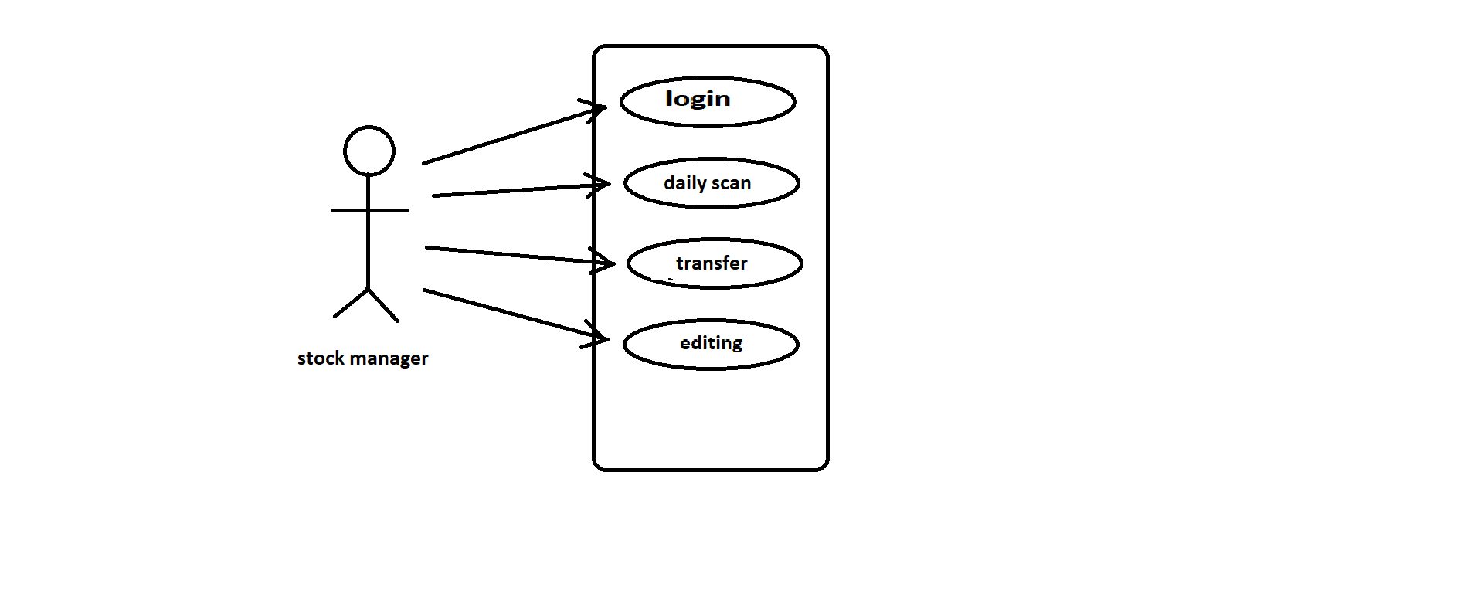

|  |  |
| --- | --- |
|  | Indicates software. |
|  | Indicates modules. |
|  | Indicates access/rights. |
|  | Indicates users. |

1. **Business data model**

**---------(N/A)---------**

Note: insufficient knowledge.

1. **Accuracy**

The accuracy will always be higher in any of the functions which can be done by the software even in printing the invoices. All the automatic processes will be completed with very high level of accuracy in the results generated by them.

1. **Impacts**

**---------(N/A)---------**

Note: Software is being made first time.